Installation Guide

For

Intelligent Known Error Database Search Engine

Version 1.0.0

Table of Contents

Table of Contents ii

Revision History ii

1. Introduction 3

1.1 Purpose 3

1.2 Document Conventions 3

1.3 Intended Audience and Reading Suggestions 3

2. Installation of Python 4-7

3. Installation of Django 8

4. Installation of NLTK 8

5. Installation of openpyxl 8

Appendix A: Glossary 9

Appendix B: Analysis Models 9

Appendix C: To Be Determined List 9

Revision History

|  |  |  |  |
| --- | --- | --- | --- |
| **Name** | **Date** | **Reason For Changes** | **Version** |
|  |  |  |  |
|  |  |  |  |

# Introduction

## Purpose

This document is for the Intelligent Known Error Database version 1.0.0.

This documentation describes the installation required for the Intelligent KEDB. The IKEDB allows performing search about known errors in unstructured data and getting a valid workaround.

## Document Conventions

Throughout this document the following conventions have been used:-

* Font : Times New Roman
* Main Headings : Size 18
* Sub-Headings : Size 16
* Rest of the document : Size 14
* Words in Bold are important and have been formatted to grab the attention of the reader.

## Intended Audience and Reading Suggestions

This document is meant for users, developers, project managers, testers and documentation writers. The document aims to explain in an easy manner, the basic installation required for the IKEDB.

# Installation of Python

* Download python 2.7.8 from : <https://www.python.org/download/releases/2.7/>
* Installation

1.Download the python setup file mentioned above and run the installer.

[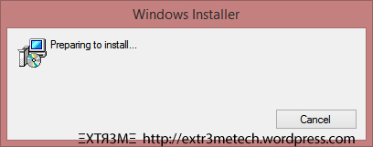](https://extr3metech.files.wordpress.com/2014/08/1.jpg)

2.Click “Next”

[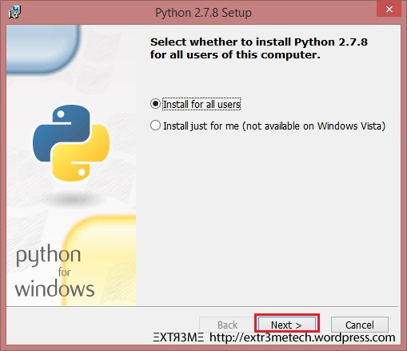](https://extr3metech.files.wordpress.com/2014/08/2.jpg)

3.Leave it to the defaults and then click “Next”

[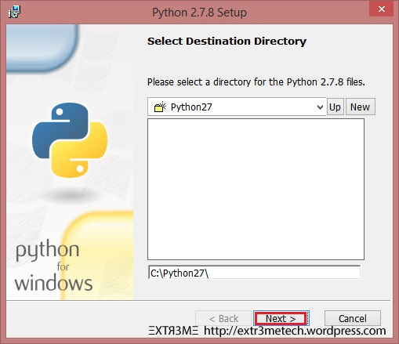](https://extr3metech.files.wordpress.com/2014/08/3.jpg)

4.Now in customize screen,you may see a RED X next to “Add python.exe to path”

[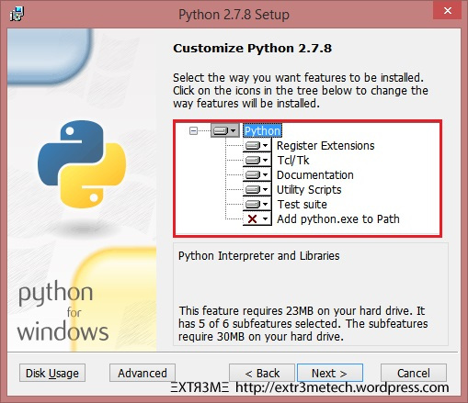](https://extr3metech.files.wordpress.com/2014/08/4.jpg)

5.Clicked on the RED X and then select the first option “will be installed on local hard drive”.

[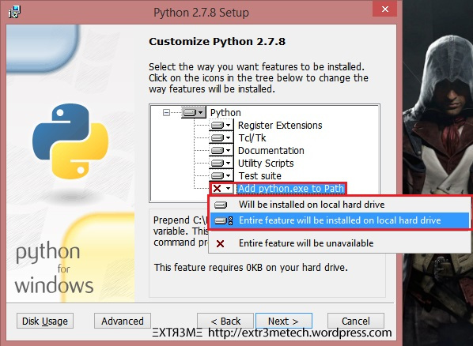](https://extr3metech.files.wordpress.com/2014/08/5.jpg)

6.So finally you will have the below screen:

[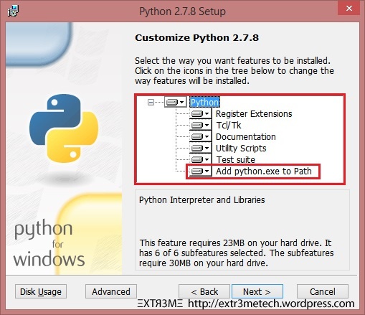](https://extr3metech.files.wordpress.com/2014/08/7.jpg)

7.Then click on “Next” and follow the on screen instructions:

[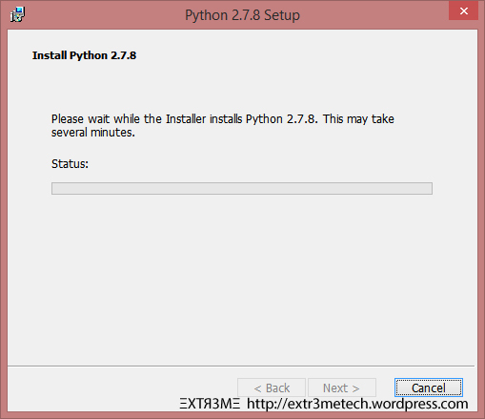](https://extr3metech.files.wordpress.com/2014/08/8.jpg)

8.Finally click on “Finish”

[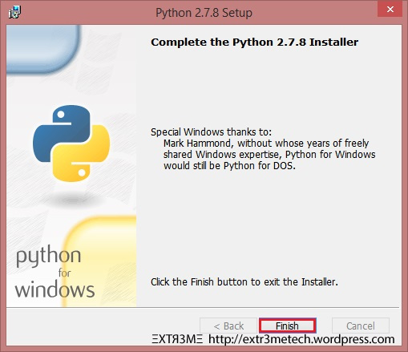](https://extr3metech.files.wordpress.com/2014/08/9.jpg)

# Installation of Django

* Download django from : <https://www.djangoproject.com/download/>
* Install pip on your machine : <https://pip.pypa.io/en/latest/installing/>
* In the command prompt execute the command : pip install django

# Installation of NLTK

# Download nltk from : <https://pypi.python.org/pypi/nltk>

* In the command prompt execute the command:

import nltk

nltk.download()

# Installation of openpyxl

* Download openpyxl from : <https://pypi.python.org/pypi/openpyxl>
* Extract the downloaded TAR file
* Open command prompt
* Navigate to the folder that you extracted in step 2
* Then type the command to install openpyxl: python setup.py install

Appendix A: Glossary

<Define all the terms necessary to properly interpret the DOCUMENTATION, including acronyms and abbreviations. You may wish to build a separate glossary that spans multiple projects or the entire organization, and just include terms specific to a single project in each DOCUMENTATION.>

Appendix B: Analysis Models

<Optionally, include any pertinent analysis models, such as data flow diagrams, class diagrams, state-transition diagrams, or entity-relationship diagrams.>

Appendix C: To Be Determined List

<Collect a numbered list of the TBD (to be determined) references that remain in the DOCUMENTATION so they can be tracked to closure.>